# Mysql-day1——【2020-06-01】：

1. mysql.ini需要怎么修改使其生效？

默认没有my.ini

百度搜一个，保存在mysql安装目录下，重启mysql my.ini才会生效

Windows下

net stop mysql

net start mysql

1. 查看下mysql的版本号

Select VERSION();

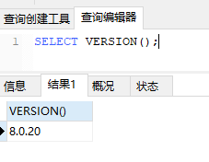

1. SQL简述--1.SQL的全称？--2.是过程性语言还是非过程性语言 --3.SQL的分类

SQL：Structured Query Language

SQL是非过程化的语言

SQL的分类：

数据定义语言DDL：CREATE、DROP、ALTER

数据查询语言DQL：SELECT

数据操纵语言DML：INSERT、UPDATE、DELETE

数据控制功能DCL：GRANT、REVOKE、COMMIT、ROLLBACK

1. 修改下mysql用户root的密码

首先，在my.ini中的[mysqld]下添加

sql_mode=STRICT_TRANS_TABLES,NO_ZERO_IN_DATE,NO_ZERO_DATE,ERROR_FOR_DIVISION_BY_ZERO,NO_ENGINE_SUBSTITUTION

不然会报错

ALTER USER'root'@'localhost' IDENTIFIED BY 'talent1234';

# mysql-day2——【2020-06-02】

1. 创建mydb1数据库，并查看数据库

CREATE DATABASE mydb1;

SHOW DATABASES;

1. 创建表employee:

id,int

name,varchar(30),

sex,char(5)

birthday,date

job,varchar(50)

salary,double

resume,text

USE mydb1;

CREATE table IF NOT EXISTS employee(

id INT NOT NULL PRIMARY KEY AUTO_INCREMENT,

name VARCHAR(30),

sex CHAR(5) DEFAULT '男',

birthday DATE,

job VARCHAR(50),

salary DOUBLE,

resume TEXT

);

1. 往employee插入3条数据，修改某条数据的birthday为2000-01-01.

INSERT INTO employee

(name, birthday, job, salary, resume)

VALUES

('zhangsan','2020-06-01', 'IT', 8000, '摘要'),

('lisi','2010-06-01', 'IT', 10000, '摘要'),

('wangwu','2000-06-01', 'IT', 9000, '摘要');

UPDATE employee SET birthday='2000-01-01' WHERE id =1;

SELECT * FROM employee;

1. 删除employee，删除mydb1

DROP TABLE employee;

DROP DATABASE mydb1;

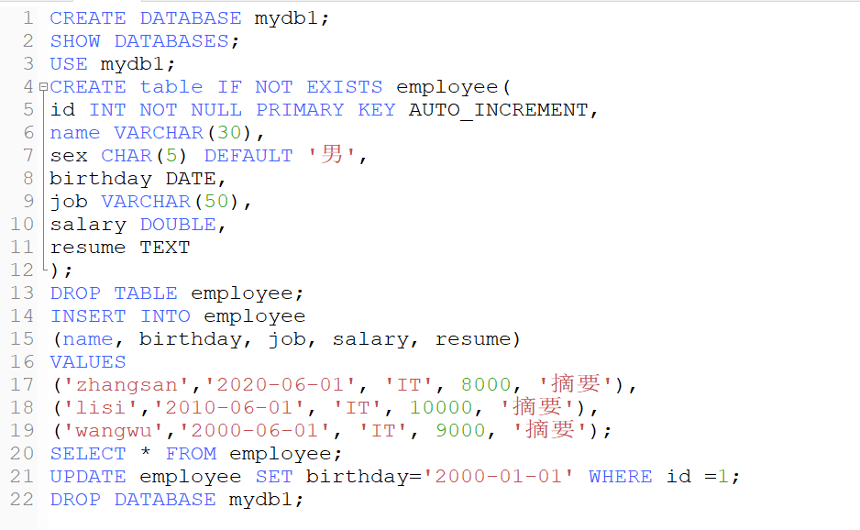

# mysql-day3——【2020-06-03】

CREATE DATABASE mydb;

SHOW DATABASES;

USE mydb;

CREATE TABLE employee (

id INT ( 10 ) NOT NULL UNIQUE PRIMARY KEY AUTO_INCREMENT,

name VARCHAR ( 30 ),

sex CHAR ( 5 ),

birthday date,

job VARCHAR ( 50 ),

salary DOUBLE,

resume text

);

INSERT INTO employee ( name, sex, birthday, job, salary, resume )

VALUES

( "shd", "男", '2019-08-31', "研发工程师", 90, NULL ),

( "jj", "女", '2019-09-02', "测试工程师", 100, "我是焦洁" ),

( "qcp", "女", '2019-09-02', "测试工程师", 99, "NULL" ),

( "qxl", "女", '2019-12-16', "自动化测试工程师", 98, "我是强小林" ),

( "wp", "男", '2020-03-02', "测试工程师", 97, "我是王鹏" ),

( "cfb", "男", '2020-04-08', "自动化测试工程师", 96, NULL );

1. 查询employee  表name中包含'工程师'的所有数据。

SELECT * FROM employee WHERE job like '%工程师%';

1. 按照salary分组并统计个数

SELECT salary, count(*) FROM employee GROUP BY salary;

1. 筛出resume不为空，sex为女，再按照salary正序排列

SELECT * FROM employee WHERE resume IS NOT NULL AND sex = '女' ORDER BY salary ASC;

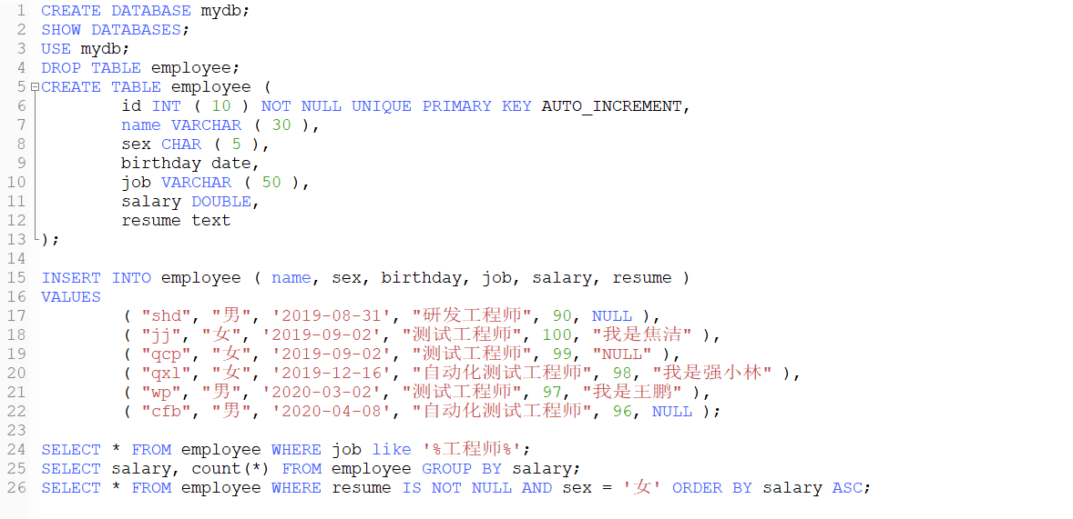

# mysql-day4——【2020-06-04】

1.查询显示出code_study.id,code_study.name,study_web.price 在一张表里。

说明：分别用INNER JOIN、WHERE、LEFT JOIN、RIGHT JOIN去实现。

SELECT code_study.id, code_study.name, study_web.price FROM code_study INNER JOIN study_web ON code_study.name = study_web.name;

SELECT code_study.id, code_study.name, study_web.price FROM code_study LEFT JOIN study_web ON code_study.name = study_web.name;

SELECT code_study.id, code_study.name, study_web.price FROM code_study RIGHT JOIN study_web ON code_study.name = study_web.name;

SELECT code_study.id, code_study.name, study_web.price FROM code_study, study_web WHERE code_study.name = study_web.name;

